Verif.ai Functional Document

Scope Enhancement wrt UPI Channel

SL | Version | Date | Modification | Prepared By
1 | V1 | 30-Dec-2025 | Initial Draft | PS
2 | V2 | 06-Jan-2026 | - Rollback Process Added  - Bulk Upload File Format Added | PS

- Introduction: This document details out the first set of enhancement to be done to the Recon Application – UPI Process.
- Functional Flow - Steps
  - File Upload
  - PGP Decryption
  - File Validation
  - Data Ingestion
  - File Dashboard
  - Run Recon
  - Output (Reports) Generation
  - TTUM Posting & Settlement
  - GL Justification
  - Dispute Management
- List of Files required for UPI Reconciliation (3 - way Recon):
  - NPCI / Network Files
      - NPCI Raw File – This is a system generated granular level file containing all the transaction data exactly processed by the NPCI. The Raw file will be provided separately for Remitter & Beneficiary transactions. The format of Raw File is included as Annexure – I
      - NPCI Merchant Transaction File - A filtered and formatted file derived from NPCI data, focused only on merchant transactions.
      - NTSL File/ DSR Report: is the final settlement file that specifies net debit / credit obligations of each participant (bank / PSP) for a given settlement cycle. NPCI will provide the DSR/NTSL file in an excel format containing net settlement position after netting the acquiring, issuing transactions disputes/adjustments, penalties, customer compensation amount, interchange, service tax, and switching fees.
      - Adjustment File/ Report:
Outward Transactions:
        - Debit Reversal Confirmation (DRC): If any transactions settlement is claimed by NPCI earlier but has now reversed due to any of the below reasons,
        - Remitter is debited but unable to credit to the beneficiary (RET cases)
        - A transaction was timed-out / in dispute and later resolved in remitter’s favor.
In the above cases, the amount claimed by NPCI earlier is returned to the remitter Bank, and the information will be available in the Adjustment File. Remitter Bank has to return/ credit the amount back to the customer (remitter) and confirm to NPCI through DRC file (Annexure IV - Bulk Upload).
Return Reversal Confirmation (RRC): Credit Adjustment raised by NPCI for full or partial refund of amount to the remitter. These transactions will be a part of Adj file. Remitter Bank refund/ return the amount to the remitter and provide a confirmation to NPCI through RRC file (Annexure IV - Bulk Upload).
Explained with an example below:
When you buy 5 items from an online shopping site and pay through UPI transaction, your bank (Remitter Bank) debits your account and the merchant account is credited. Suppose you return any of the 5 items (partial) or all 5 items (full), the merchant (beneficiary) bank raised the Credit Adjustment request to NPCI. NPCI debits the merchant Bank and credits the remitter bank with this amount. The status of these transactions is found in the Adjustment file, downloaded from NPCI portal. The remitter bank has to refund this amount to the remitter and provide a confirmation through RRC file upload. – Sample file: Annexure 4: Adjustment File – NPCI Bulk Upload Format
Inward Transactions:
Transactions with the RC as ‘RB’ – Deemed accepted to be identified and based on the status in the CBS (GL) to be categorized as 102 & 103.
        - Transaction Credit Confirmation (TCC) 102 & 103 Adjustment File (To be uploaded onto the NPCI Portal): In inward transaction, due to certain network error, NPCI is unable to fetch the real-time response from the beneficiary bank. At such instances, NPCI marks such transactions with RC ‘RB’ which indicates that the transaction is considered to be a deemed success and NPCI would collect take the settlement against this transaction. In such scenarios, the reconciliation of inward transaction will have an additional step of identifying the ‘RB’ transactions in the Raw file, verifying it with the CBS and Switch File for the status with below Action points.
        - If the Transaction is marked as RB in NPCI file and the CBS also has a successful credit entry, then such transactions must be categorized under TCC 102.
        - If the Transaction is marked as RB in NPCI file and the CBS do not have a credit entry, then a TTUM for crediting the amount to the beneficiary must be prepared and post successful credit, such transactions must be categorized under TCC 103.
        - Return (RET) Transactions: Transactions where Beneficiary Bank is unable to credit the transactions to the beneficiary account due to certain reasons line account inactive/ frozen etc., the RET file must be prepared and uploaded to NPCI. NPCI debits the amount of such transactions and returns back to the remitter bank as part of Adjustment file.
Sample file: Annexure 4: Adjustment File – NPCI Bulk Upload Format

  - Switch File: Bank’s Transaction Switch Log: Single file with data dump of all the transactions (Fin + non-fin) processed by the Switch. (Sample File Attached. However, this file must be flexible for modifications).
  - CBS File:
- Core Banking System logs: 2 files one of Payable/ Outward GL and other one is for Receivable/ inward GL. (Sample file Attached However, this file must be flexible for modifications).
- CBS Closing Balance (Option to manually update the closing balance of data fetch provision through API).
  - File Count for UPI Reconciliation:

Cycle: 10 per day.
File Name | Inward | Outward | Total Count
NPCI Raw | 10 | 10 | 20
NPCI Merchant | 10 | 10 | 20
NTSL | 10 |  | 10
DRC | 10 |  | 10
RRC | 10 |  | 10
Adjustment Report | 10 |  | 10
CBS | 1 | 1 | 2
Switch | 1 |  | 1

- Steps Defined:
  - File Upload:
This is the process of fetching the required files from various sources. The application must be equipped to pull the file from the source by any or multiple option given below. Manual Upload option from the application front-end can be provided as fall – back/ secondary option for file upload.
- SFTP + Auto Scheduler: Bank team dumps the files into the SFTP and the Application scheduler picks the files as per the defined timeline. The scheduler will also have the re-try option if the files are not found during the first attempt.
- DB Link: This is done using the API integration where the required fields are extracted from the source database.
- Robotic Process Automation (RPA): -> On hold for now
- Manual Upload: Front-end option given to the user to search & Upload File from Local PC/ SFTP.
  - PGP Decryption:
The Files shared by NPCI will be encrypted using PGP Encryption. The application must be capable enough to decrypt this file for utilization. -> On hold for now.
  - File Validation:
Validation/ Sanity Check Rules:
All files:
- Check the file format (Excel, CSV, txt etc).
- Check for the file structure. The availability of the fields configured by the User, for reconciliation must be present in the files/ data.
- Accuracy of data. Identify for junk, incomplete, missing fields and notify the user.
- Identify all financial transactions in Switch & NPCI files. Logic below;
  - (Both files) All transactions with the Tran Amt value > 0
  - Tran Type must be equal to ‘U2’ for Merchant Data (Issuer & Acquirer) and ‘U3’ for Raw data (Issuer & Acquirer).
  - Check if all the financial transactions have accurate Response Codes (RC) – RC List attached as Annexure

NPCI Files
- Validation with Raw & NTSL files – The summarized value of count & amount of transactions must be matched with the ‘Approved Transaction Amount’ in the NTSL File. Mismatch to be notified to the User.
NTSL field for reference below. File attached in Annexure.

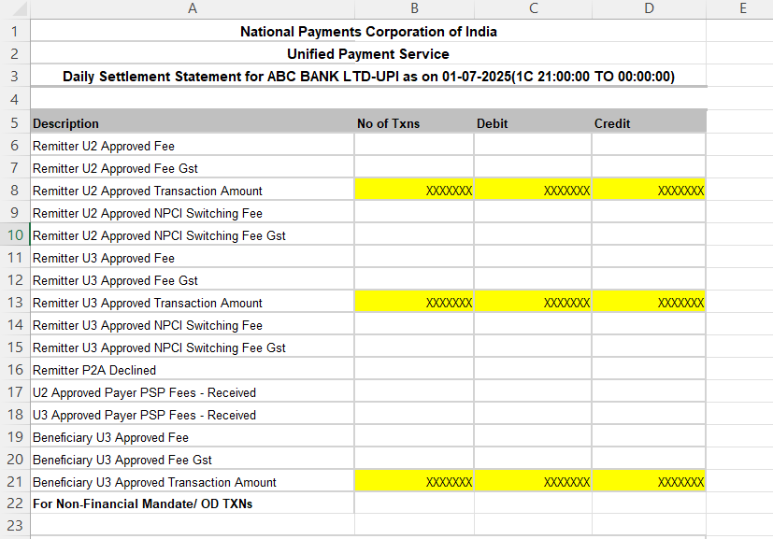

  - Data Ingestion:
The validated data is ingested into the application for further processing. Once the data is ingested into the application, the first set of reports must be generated which is called the ‘Listing Reports’
The data ingested must be available to the user to download and verify – if required. The reports are as below:
- CBS Beneficiary Listing (Inward)
- CBS Remitter Listing (Outward)
- Switch Listing (Inward)
- Switch Listing (Outward)
- NPCI Beneficiary Listing (Inward)
- NPCI Remitter Listing (Outward)

  - File Dashboard:
This is a real-time dashboard indicating the progress of each process individually with below list of values. Cycle-wise visibility to be provided to the User.
- File Upload
- File Validation
- Data Ingestion
  - Run Recon
This is the process where actual matching of transactions happens between the files based on the pre-defined parameters called as Matching Parameters. If the transactions between all 3 files perfectly match, then they are considered to be Matched Transactions. If the transaction is present in CBS & Switch File but missing (partly or fully) in NPCI Raw, then such transactions are categorized as Hanging Transactions. Rest is categorized as Unmatched Transactions.
Recon Logics (Mentioned in sequence in which the logic must be applied):
Outward Transaction Recon:
- Cut-off transaction in NPCI Files: Declined transactions where original leg is in the current Raw file. But due to the cut-off time, the reversal leg is logged into the next cycle. In such scenario, categorize these transactions (Both Original & reversal leg) as Hanging Transactions and wait for the next cycle’s raw file to match the transaction.
- Self-Matched Transactions in Switch, CBS & Raw File (Auto-reversed transactions): Where 2 entries – one with debit & another with credit leg, with same UPI Tran ID, RRN, Tran Date and Tran Amt. Such transactions are categorized under Matched Transactions.
- Settlement Entries: Settlement entry of the previous batch in GL. (How to identify: -> The amount will be equivalent to the previous NTSL amount and there will be no RRN against this entry).
- Double Debit or Credit: Same RRN with multiple Debit/ Credit entries. Keep the entire set of the transaction (Org & duplicate) as unmatched. User to take action on such transactions manually. If user prefers to reverse the duplicate entry, TTUM must be generated.
- Normal Matching: After the above steps the remaining financial transactions are matched on one-to-one basis using the below matching rules (to be kept configurable). These matching will happen only to the transactions with the RC as ‘00’.
Matching Parameters:
Matching Type | Parameters
Best Match | UPI Tran ID, RRN, Tran Date, Tran Amt
Relaxed Match - I | UPI Tran ID, Tran Date, Tran Amt

- Deemed Accepted Matching: After matching the success transactions, the system should check for the RC ‘RB’ transactions where NPCI has deemed accepted these transactions as success. If the corresponding debit entry is already found in the CBS – remitter a/c, then categorize such transactions as TCC 102. If not, prepare a TTUM for debiting the remitter.
- NPCI Declined Transactions: Now check for all the other transactions where amount > 0; and failed in NPCI raw file. There should not be any entry available in CBS file for such transactions. If available prepare a TTUM to reverse the transaction.
- Failed Auto-credit reversal: Scenario where the NPCI file has both Dr & Cr leg but CBS has only one entry.
Once the recon process is complete, the second set of reports are generated by the application. Reports are as below:
Report Name | Process
GL vs Switch - Matched Transactions | Inward
GL vs Switch - Matched Transactions | Outward
Switch vs Network - Matched Transactions | Inward
Switch vs Network - Matched Transactions | Outward
GL vs Network - Matched Transactions | Inward
GL vs Network - Matched Transactions | Outward
GL vs Switch - Unmatched Transactions with ageing | Inward
GL vs Switch - Unmatched Transactions with ageing | Outward
Switch vs Network - Unmatched Transactions with ageing | Inward
Switch vs Network - Unmatched Transactions with ageing | Outward
GL vs Network - Unmatched Transactions with ageing | Inward
GL vs Network - Unmatched Transactions with ageing | Outward
Hanging Transactions | Inward
Hanging Transactions | Outward

Treatment of Unmatched transactions & TTUM Preparation:
- Forced Matching: User intervention to forcefully match a transaction in 2 files. Application to allow such matching only if the amount in both the files is same.
- Hanging Transactions: Transactions found in CBS & Switch file but is missing in NPCI Raw. Categorize such transactions as ‘Hanging Transaction’ and wait for the next cycle to get these transactions matched. If the transactions are not found in the next 2 cycles, then considered these transactions as NPCI – Failed and take necessary exception handling action as defined below.
- Exception Handling: Action Items explained.
  - Remitter Refund TTUM: Scenario in Outward Transactions where the Remitter account is debited with the transaction amount but the transaction is unsuccessful and not claimed by NPCI. TTUM to be generated for crediting the amount back to the Remitter. Accounting entries provided in the Annexure
  - Remitter Recovery TTUM: Scenario in Outward Transaction where the remitter recovery has failed but the Transaction is successful and is claimed by NPCI. TTUM to be generated for debiting the customer account. Accounting entries provided in the Annexure
  - Transaction Credit Confirmation (TCC) 102 & 103 Adjustment File (Inward Transactions only)
    - If the Transaction is marked as RB in NPCI file and the CBS also has a successful credit entry, then such transactions must be categorized under TCC 102.
    - If the Transaction is marked as RB in NPCI file and the CBS do not have a credit entry, then a TTUM for crediting the amount to the beneficiary must be prepared and post successful credit, such transactions must be categorized under TCC 103.
  - Beneficiary Recovery TTUM: A particular inward transaction which is marked failed by the NPCI, but the credit is already passed on to the Beneficiary Account. A Beneficiary Recovery TTUM to be generated for reversing this transaction.
  - Beneficiary Credit TTUM: A particular inward transaction which is approved by NPCI but the amount is not credited to the Beneficiary. A beneficiary credit TTUM is generated in this scenario.
  - TTUM Reverse Feed – Once the TTUMs are posted onto the CBS, the CBS generates a reverse feed regarding the actual state of the exception handling which has been carried at the CBS level. Transaction wise ‘Success’ or ‘Failed’ response is generated. For failed scenarios, the Reverse feed also provides the reason – like inadequate fund, account frozen or blacklisted etc.
  - Switch Update File: This is an output generated from the recon application for uploading onto the Switch Portal for correcting / updating the status of the transactions from Failed to Success or vice-versa.
The TTUM & Adjustment File formats are attached below as Annexures.
The Accounting Entries indicating the Debit & Credit Accounts are attached as Annexures.

The Exception Handling scenarios are explained in brief in the below table.
CBS (GL) | Switch | NPCI (Raw) | Outward | Inward
Success | Success | Success | No Action -> Matched Transactions | - No Action if the RC is 00  - Generate TCC 102 File if RC is RB
Success | Success | Failed | Generate  - Remitter Refund TTUM  - Switch Update File | Generate  - Beneficiary Recovery TTUM  - Switch Update File
Success | Failed | Success | Generate Switch Update File | - No Action if the RC is 00  - Generate TCC 102 File if RC is RB  - Generate Switch Update File (Post TTUM Reverse Feed)
Success | Failed | Failed | Generate Remitter Refund TTUM | - Generate Beneficiary Recovery TTUM  - Switch Update File
Failed | Success | Success | Generate  1) Remitter Recovery TTUM  2) Switch Update File | Generate  - Beneficiary Credit TTUM  - TCC 103 File Post TTUM Reverse Feed)
Failed | Success | Failed | Generate Switch Update File | Generate Switch Update File
Failed | Failed | Success | Generate  1) Remitter Recovery TTUM  2) Switch Update File | Generate  - Beneficiary Credit TTUM  - TCC 103 File Post TTUM Reverse Feed)  - Switch Update File (Post TTUM Reverse Feed)
Failed | Failed | Failed | No Action -> Matched Transactions | No Action -> Matched Transactions
In the above table, Success = RC ’00’ Any other response other than RC ‘00’ & RC ‘RB’ is treated to be Failed transactions.
Other TTUM Scenarios:
- RET File (To be uploaded onto the NPCI Portal): After receiving the reverse feed from the CBS, identify the TCC 103 transactions where Beneficiary Credit Transactions were posted through TTUM but the credit to the beneficiary account has failed due to reasons like account inactive, frozen etc. and categorize these transactions under RET (To be returned back to NPCI).
- Double Debit/ Credit Reversal TTUM: Reversal of duplicate transaction
- Failed Auto-credit/ reversal: Manually posting the transactions which has missed the transactions.
- NTSL Settlement TTUM: Verify the summarized value of Transaction count & amount in the Raw file with the NTSL data and prepare the TTUM for the fund movement from bank’s internal a/c to NPCI Settlement A/c.
- DRC: Generate a TTUM for reversing the amount to the Remitter
- RRC: Generate a TTUM for reversing the amount to the Remitter

List of TTUMs to be generated:
- Remitter Refund TTUM
- Remitter Recovery TTUM
- Failed Auto-credit/ reversal
- Double Debit/ Credit reversal
- Beneficiary Recovery TTUM
- Beneficiary Credit TTUM

Accounting entries:
Transaction/ TTUM | Debit | Credit | Execution Method
Outward Txn - Original Leg | Remitter Account | Outward/ Payable GL | Auto
Outward Txn - Auto Reversal Leg | Outward/ Payable GL | Remitter Account | Auto
Outward Txn - Failed Auto Reversal | Outward/ Payable GL | Remitter Account | TTUM
Inward Txn - Original Leg | Inward/ Receivable GL | Beneficiary Account | TTUM
Inward Txn - Auto Reversal Leg | NA | NA | TTUM
Remitter Refund TTUM | Outward/ Payable GL | Remitter Account | TTUM
Remitter Recovery TTUM | Remitter Account | Outward/ Payable GL | TTUM
Beneficiary Recovery TTUM | Beneficiary Account | Inward/ Receivable GL | TTUM
Beneficiary Credit TTUM | Inward/ Receivable GL | Beneficiary Account | TTUM
Double Debit (Reversal) - Outward Txn | Outward/ Payable GL | Remitter Account | TTUM
Double Credit (Reversal) - Outward Txn | Remitter Account | Outward/ Payable GL | TTUM
Double Debit (Reversal) - Inward Txn | Inward/ Receivable GL | Beneficiary Account | TTUM
Double Credit (Reversal) - Inward Txn | Beneficiary Account | Inward/ Receivable GL | TTUM
NTSL Settlement TTUM - Inward Txn | NPCI Settlement A/c | Inward/ Receivable GL | TTUM
NTSL Settlement TTUM - Outward Txn | Outward/ Payable GL | NPCI Settlement A/c | TTUM
DRC
RRC
The account numbers for NPCI Settlement A/c, Payable & Receivable Account with be provided by the Bank. This would be a ‘one-time’ configuration into the system. However the Remitter & Beneficiary details must be extracted from the NPCI raw file.

  - Roll-back Process:
The overall recon operation involves the below steps:
File Upload -> Run Recon -> Generate Reports & TTUM
Rollback option provides the user to undo the desired step or the entire recon.
- TTUM Roll Back -> This option must be provided only if the TTUM file is not downloaded from the application. The TTUM roll-back option must be immediately disabled once the TTUM is downloaded from the application.
- Reports Rollback -> This process involves undo–ing the reports which are prepared post reconciliation of the data.
- Recon Rollback -> Reversing the recon process, where the data is processed for categorization of transactions into matched & unmatched. Force – matched transactions must also be reversed in this case.
- File Rollback -> This process involves deleting the data uploaded into the application and allowing to upload fresh files.
- Complete Rollback -> This option must allow the user to rollback the entire process (from TTUM to File Upload) in one click.
- Also note that the entire Audit Trail of the processes must be maintained within the application.

  - GL Justification: On hold for now
  - Dispute Management: On hold for now

Annexure – I
NPCI – Raw File Format
Circular Ref: NPCI/UPI/2022-23/OC.157 dated 31st Oct 2022
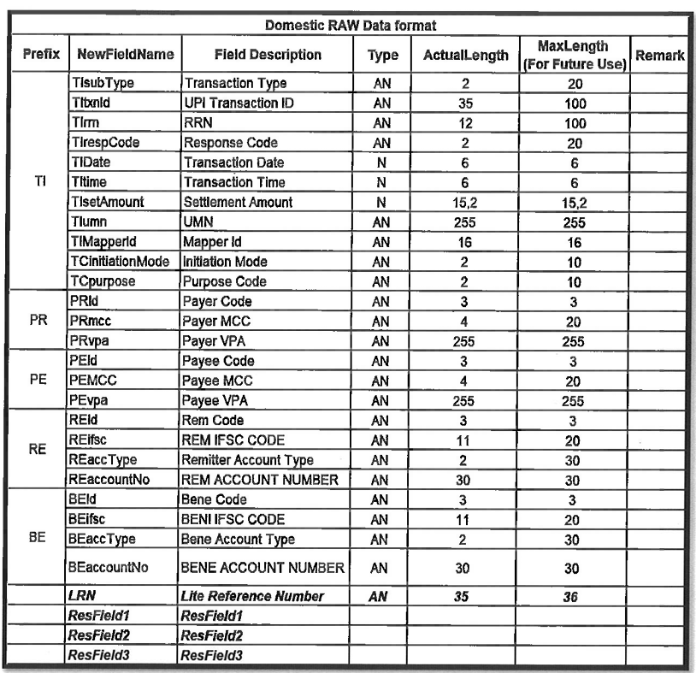
NPCI – Merchant Raw Data Format:
Description | Max Length | Typ
Participant ID | 3 | A
Transaction Type | 2 | A
From Account Type | 2 | A
To Account Type | 2 | A
Transaction Serial Number | 12 | A
Response Code | 2 | A
BENEFICIARY NUMBER | 19 | A
REMITTER NUMBER | 19 | A
Member Number | 1 | A
Approval Number | 6 | A
System Trace Audit Number | 120 | S
Transaction Date | 60 | S
Transaction Time | 60 | S
Merchant Category Code | 40 | S
Card Acceptor Settl Date | 60 | S
Card Acceptor ID | 15 | A
Card Acceptor Terminal ID | 8 | A
Card Acceptor Term. Location | 40 | A
Aquirer ID | 11 | A
Acquirer Settlement Date | 60 | S
Transaction Currency Code | 3 | A
Transaction Amount | 150 | S
Actual Transaction Amount | 150 | S
Trans Activity Fee | 150 | S
Acquirer Stl Curr Code | 3 | A
Acquirer Settlement Amount | 150 | S
Acquirer Stl Fee | 150 | S
Acquirer Stl Proc Fee | 150 | S
Acquirer Stl Conv Rate | 159 | S
PAYMENT REFERENCE | 50 | A
CUSTOMER LOCATION | 18 | A
MERCHANT LOCATION | 18 | A
OTP INDICATOR | 1 | A
ORIGINATING CHANNEL | 4 | A
MCC | 4 | A
ERROR FREE TEXT | 50 | A
RESERVED | 50 | A
RESERVED | 150 | A
RESERVED | 100 | A
RESERVED | 100 | A
RESERVED | 100 | A
Payer PSP code | 150 | A
Payee PSP code | 150 | A
UPI Transaction ID | 50 | A
Customer refernce Number | 50 | A
UPI reference code | 50 | A

Annexure – II
Sample NPCI File Formats:
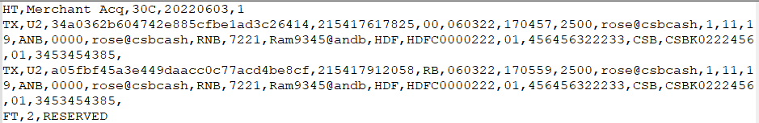
ACQUIRER MERCHANT RAW DATA V3

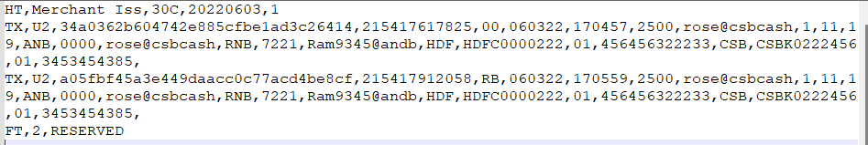
ISSUER MERCHANT RAW DATA V3

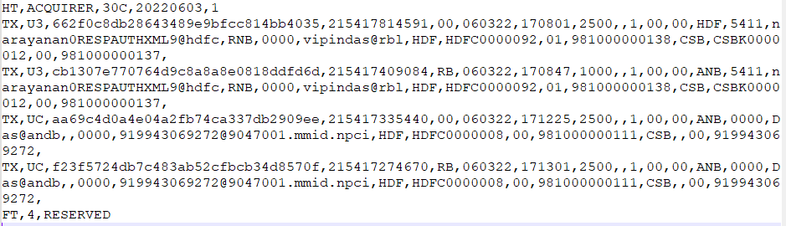
ACQUIRER RAW DATA V3

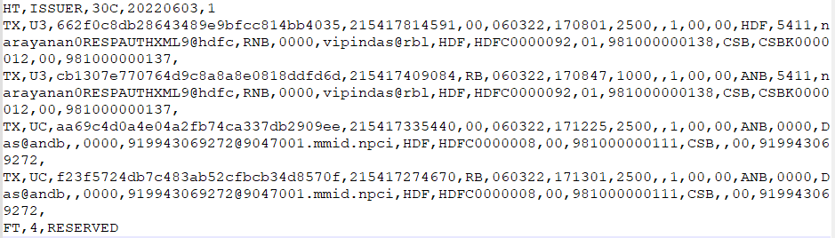
ISSUER RAW DATA V3
Annexure - III

Adjustment Report (Format):
Data in blue share is the column header and the white section is the sample data.
Txnuid | Uid | Adjdate | Adjtype | Remitt  er | Benefici  ery | Resp  onse | Txn  date | Txnt  ime | RRN | Termin  alid | Ben_Mo  bile_No | Rem_Mobile_N  o
XXXXXXX | XXXX XXX | DD-MM- YYYY | Arbitrati  on Raise | ABC | DEF | 00 | DD-  MM-  YYY Y | HH:  MM: SS | XXXX  XXXX XXXX | XXXXX | XXXXXX XXXXXX XXXXXX  X | XXXXXXXXXXXX XXXXXXX
Chbdate | Chbr ef | Txnamo unt | Adjamo unt | Rem/P  ayeePS P_Fee | Ben_Fee | Ben_  FeeS W | Adjf ee | Npci fee | Remf  eeta x | Benfe etax | Npcitax | Adjref
- | - | 15000.0  0 | 15000.  00 | 0.00 | 0.00 | 0 | 0 | 0 | 0 | 0 | 0 | XXXXXXXXXXXX XXXXXXXXXXXX  XXXXXXXXXXXX
Bankadjr ef | Adjpr oof | Compen  sation amount | Adjust ment raised  time | No of Days for  Penalty | SHDT73 | SHD T74 | SHD T75 | SHD T76 | SHD T77 | Transa  ction_ Type | Transac tion Indicato  r | Beneficiary  Account number
 | XXXX  XXX | 0 |  | 0 |  |  |  |  |  | U2 | PAY | XXXXXXXXXXXX  XXXXXXXX
Remitter Account  number | Aadh ar Num  ber | Mobile Number | Payer PSP | Payee PSP | UPI  Transact ion ID | Virtu al Addr  ess | Disp ute  Flag | Rea son Cod  e | MCC | Origin ating Chann  el
XXXXXXX XXXXXXX  XXXXXX |  | XXXXXXX XXXXXXX  XXXXXX | ABC | DEF | XXXXXXX XXXXXXX  XXXXXX |  | AR | 110  0 | 5816 | UMOB

Currently for ‘Adjtype’ we will only consider ‘Credit Adjustments’, ‘TCC & RET’ Txns.
Sample File:
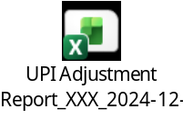
Annexure IV
Adjustment File – NPCI Bulk Upload Format
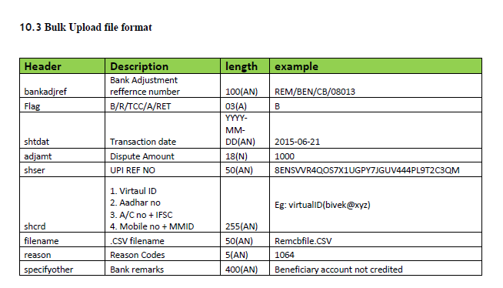
Header | Description | length
Bankadjref | Bank Adjustment Reference Number | Length 100 (AN)
Flag | DRC/RRC/Cr Adj/ TCC/RET | Length-03 (A)
shtdat | Txn Date | YYYY-MM-DD (AN)
adjsmt | Dispute Amount | (N)
Shser | RRN | Length -50 (AN)
Shcrd | 1. P2P - NBIN + Mobile Number (19 Digits) | Length-53 (AN)
 | 2. P2A - NBIN + Account Number (19 Digits)
 | 3. P2U - NBIN + Aadhar Number (19 Digits)
File Name | .CSV file name | Length-50(AN)
reason | Reason Codes | Length-05 (AN)
specifyother | Bank Remarks | Length-400 (AN)

Currently for ‘Flag’ Header, only consider DRC, RRC, Credit Adjustments, TCC & RET. Remaining are related to Dispute which we shall take up at the later stage.

Format:
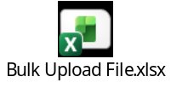
Annexure V
NTSL File:
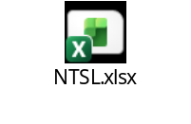
Annexure VI
- CBS Sample Files:
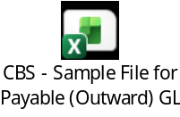
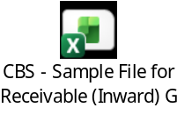

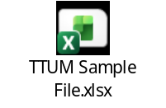

- Switch Sample File
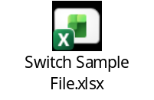

Please note that the Switch & CBS file structure to be kept configurable.

